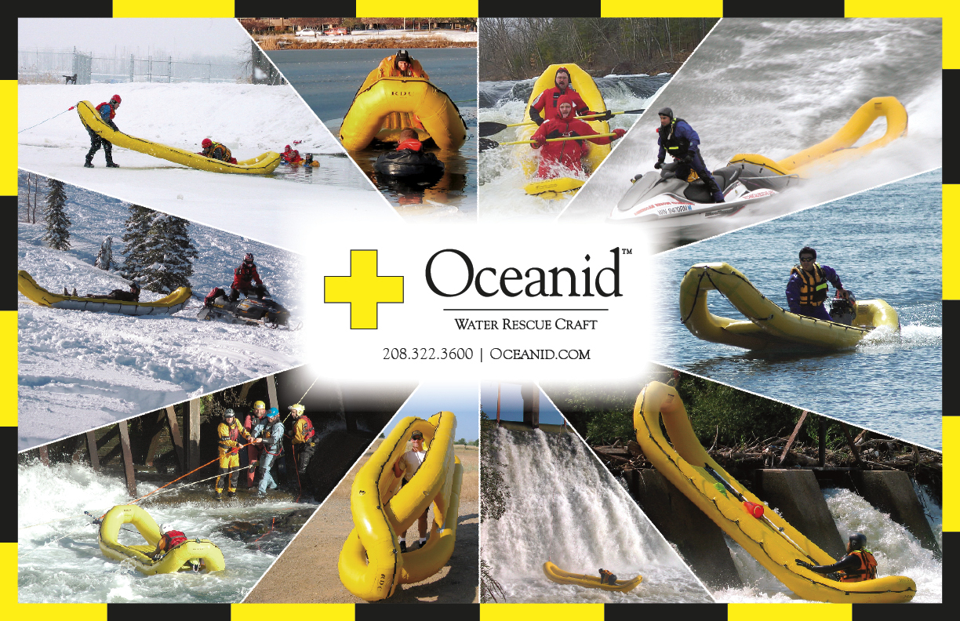
Areas of Operations – RDC Applications
Many boats handle a single rescue situation fine; the RDC handles multiple rescue situations exceptionally well.*

Swift Water: The RDC provides a means to reach a victim and safely retrieve them. It is easy to control and very stable. It ferries like a canoe, can be shore controlled by one rescuer and on the scene in seconds.
Low Head Dam: The RDC is the ultimate weapon when it comes time to battling a low head dam accident. The upswept ends and open floor create an inherently stable craft that strongly resists flipping even when thrust into a pour-over. In is the only boat that instantly voids water, making it 100% ultra self-bailing. It is designed to be ‘lowered’ to the pour-over from downstream under the control of ropes.
Ice: The RDC is simply the best, fast-response, ice rescue craft available at any price. The craft surrounds one or more rescuers, in an ultra buoyant and protective inflated perimeter. The rescuer(s) can easily carry the 50-pound RDC to the edge of the ice, step into the craft, and run out across the ice to reach a victim. While on the ice, they are protected from falling through a fracture into the water.

Rescue Platform: The RDC, with its few inches of freeboard and dual open end access is exceptional as a tender to a larger boat with “V” bottom, high freeboard, reduced maneuverability, and hard bottom or prop hazard. The RDC can be towed behind or stowed aboard the motorized vessel. The RDC can easily accommodate multiple rescues and victims simultaneously.
Dive Platform: The RDC is a stable diving platform that is as easy to enter as it is to exit. Large openings on both ends allow the diver to enter the craft by only lifting a few inches out of the water with tanks in place. The craft can be paddled by a surface support crew or the dressed-out divers themselves.
Snowmobile Towable Sled: The RDC tows incredibly well behind a snowmobile when used for patient transport or equipment hauling. Weighing only 50 lb and with its 48" wide track area, the RDC floats extremely high on the snow, creating substantially less drag for the snowmobile than the more typical "hard" sleds weighing 250+ lb that ski on narrow runners and dig deep tracks into the snow.

Designed For Rescue
The RDC is a radical departure from the practice of drafting recreational craft into rescue service. This boat was designed specifically for water related rescue situations.*

Marsh, Sink Holes, Swamp: The RDC can get out through thick reeds and provide a super stable and safe working platform.
PWC Towable Craft: The RDC can be towed at high rates of speed easily behind a PWC, providing a multiple victim rapid response to a capsized boating accident. There is simply not enough passenger room on the craft to exceed its flotation capability.
Sea and Ocean: The RDC can be paddled out to a victim from shore under moderate surf conditions, or towed easily by a PWC. Multiple craft can be carried in the deflated mode and quickly inflated with diving tanks and delivered. PWCs can tow the craft out to harbor emergencies.
Body Retrieval: Sometimes you need to retrieve a body that may be in varying degrees of decomposition. The RDC will make the unpleasant task a lot easier.
Mixed Waters and Transitions: The RDC is an ideal choice for mixed environment rescue, like ice-to- water-to-ice, whether planned or emergent.
K-9 Platform: The RDC provides a stable work environment for rescue or cadaver dogs, handlers, and equipment. For K-9 security a carpet section can easily be fastened to the deck.
Flood and Debris Waters: The RDC is an excellent flood response vessel as it can easily handle multiple victims, provide protection from float debris, and is easy, light, and quick to portage or transport.
Estuaries and Tidal Lands: The RDC is not only effective in shallow draft waters as a rescue craft, but does little to disturb any sensitive impact areas, as there are no hard or extended points below the surface.
Patient Litter: A victim on a backboard is helpless if, somehow, he falls into the water. Secured to the RDC, they are safe as they could possibly be in a bad situation. Two rescuers can easily use the craft as a litter.
Mud: The RDC effectively travels over viscous waters too; mud is not an obstacle. This allows rescuers to reach the victim quickly and safely.

Built Rescue Tough
The RDC is designed to withstand severe use conditions for many years.
To achieve this, we assemble each craft with the finest, most advanced materials
and use well-tested construction techniques.*

x The RDC, Rapid Deployment Craft, is the safest, most durable, easiest to use, rescue boat ever made. It is 100% and ultra-fast self-bailing. It works in so many applications that it is the only non-motorized boat a department may need.
x The RDC has extremely rockered (upturned) ends. They allow the rescuer to "drive" the boat's open end over the victim while the victim's head remains above water at all times.
x It also allows a rescuer to reach forward into a pour-over while still safely centered in the boat. The floor is open at each end, allowing 2 entry points.
x The freeboard height is only inches, enabling a rescuer to easily pull a victim into the boat. This also allows a diver, with tanks on, to pull themselves into the craft with minimal effort.
x The two entry portals on either end also act as carrying points, which provide a perimeter of safety in case of sudden ice failure or mud sinking.
x Carrying the RDC is like using a litter with long handles, which, by the way, is one of its many uses.

x The RDC will store in a 2' cube, inflate in a heartbeat, and can easily be carried by one person.

x The most common way to carry it is deflated and stored in a rescue boat or vehicle. Think about how often you arrive at a scene and cannot find a place to launch your motorized boat. This is why you should have the RDC along on every call.

*Abbreviated from our website; read more at www.oceanid.com
x The RDC fabric is the most durable in the industry. It is a PU/PVC/polyester alloy material with all the seams being welded and taped for ultimate strength and air retention. No glue or adhesive is used, so our seams attain the same strength as the fabric, which means there are no weak links in our boats.

x The urethane coating also contains more UV inhibitors than any other material on the market. This allows prolonged sun exposure with no fabric degradation, as occurs with traditional rubber boats.
x Our floor is also very special. It is an I-Beam Design that, with very little air pressure, can become rock hard. (This enhances stability and makes the RDC an excellent litter for carrying an incapacitated victim.)
x The RDC is one tough cookie. It may last so long that you will forget all about us. That is our goal and our greatest compliment.

.

Length | 15'4"
Width | 48"
Tube Diameter | 12"
Floor Length | 8'
Access Holes | 22"x40"
Weight | 50 lbs.
No. of Air Chambers | 3
Buoyancy | >2000+ lbs.
Fabric | 35oz. PU/PVC
Warranty, with registration | 5 years

OCEANID 6140 North Drake Way, Boise ID 83714 USA

